Columbian exchange project

What is your favorite meal? Have you ever wondered where it originated? Chances are the ingredients in your favorite dish came from places all over the globe that were brought together through the Columbian Exchange.

Project Instructions: This sheet must accompany your project for full credit.
- ON A PIECE OF WHITE PAPER Use textbook or feel free to do additional research, but do not copy and paste information from the Internet and claim it as your own. (45 points)
- Define Columbian Exchange
- Explain the impact of the Columbian Exchange on Africa, Europe, and the New World.
- What “items” were a part of the Columbian Exchange?
- Was the Columbian Exchange a positive thing? Negative thing? Both? Explain.

- Write-out the recipe for your favorite food. (15 points)

- Identify the starting point of the ingredients in this dish. Include this information on your one pager! (30 points)
- Where did each item first come from?
- Tell where the food is grown today, how it is used, or any interesting facts.
- Include pictures or a photos of your food on your one-pager.(10 points)
- Can be drawn, printed off computer and glued/taped on, from a magazine, etc.

The one page with the questions and starting point of each ingredient and the notecard with recipe are all due ___________________________________

Rule for recipe:
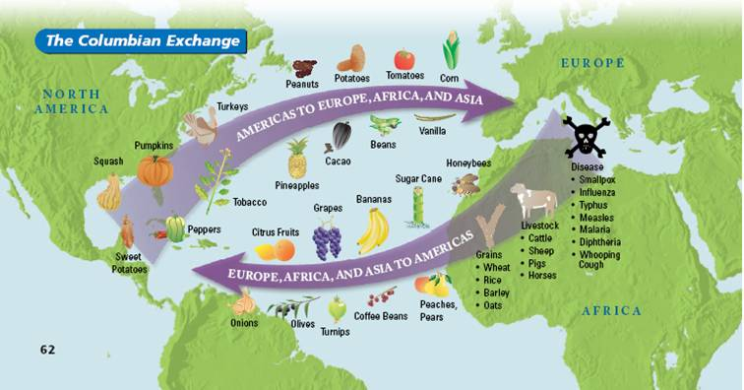
- Your recipe may combine ingredients from Old and New Worlds however, one ingredient, such as the tomato for example, should be a primary ingredient from one place.
INGREDIENT EXAMPLES:
-Pumpkin -Vanilla
-Turkey -Beans
-Sweet Potato -Coffee Bean
-Avocado -Peach
-Pineapple -Banana
-Squash -Grape
-Cacao Bean -Pig
-Potato -Wheat
-Corn -Sugar
-Tomato -AND MANY MORE!!!

