What are the common factors that prompted human migration up to 1200?

Directions: Using the web resources listed below:
1. Mark Polynesian migration routes on the SE Asia and Australia map you create.
2. Use information from the sites below for your group to identify the factors that prompted migrations within Polynesia and Sub-Saharan Africa. List these on your map.
3. Mark Bantu migration routes on your map of Africa.
4. Create a Venn diagram or T-chart to compare the evidence you find about both regions. Are the factors more similar or more different? Write a sentence explaining your answer.

Focus Questions: ANSWER THESE QUESTIONS IN A PARAGRAPH EACH AFTER YOU COMPLETE THE MAP QUESTIONS
o Define the term migration.
o What are the similarities and differences in the factors that prompted migrations within Polynesia and
Sub-Saharan Africa?
o What are the similarities and differences in the issues historians have in analyzing those factors?

Polynesian Migrations

Wayfinders: A Pacific Odyssey- Site contains information about European explorers, oral traditions, experimental voyaging, and archaeology.

Facts about Polynesian Migration- Users can locate information about physical and biological evidence, language, and accidental versus carefully planned migration.

Polynesian Voyaging Society- Contains details of modern day voyages, construction drawings of voyaging boats, life aboard a canoe, migration information, stories and proverbs.

Oceania Timeline- From A.D. 300 to 1986.

Oceania, 8000-2000 B.C.- This website is hosted by the Metropolitan Museum of Art.
National Geographic Xpeditions- Polynesian web quest for high school students.

Bantu Migrations

The Story of Africa- This web site hosted by the British Broadcasting Network, contains audio clips to enhance the user’s knowledge of the Bantu.

Bantu Languages- Wikipediainformation about Bantu languages. Bantu Expansion- Wikipedia article about Bantu expansion.
History of Bantu Migrations- This site contains information about languages, ways of life, religion, social and political factors, and full color maps.

Other Sites of Interest

Kon Tiki- YouTube video of Thor Heyerdahl’s voyage on the Kon Tiki in 1947. Look for the parrot that made the journey with the men!

Kon Tiki Museum- This is the official site of the museum in Norway. The original boats from
Heyerdahl’s various expeditions are housed in the museum.

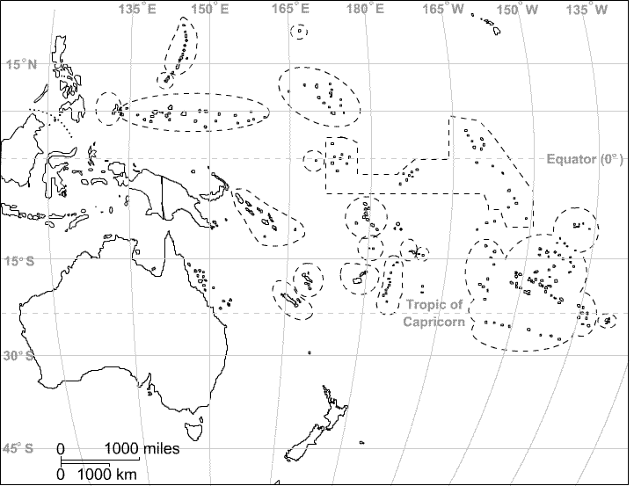

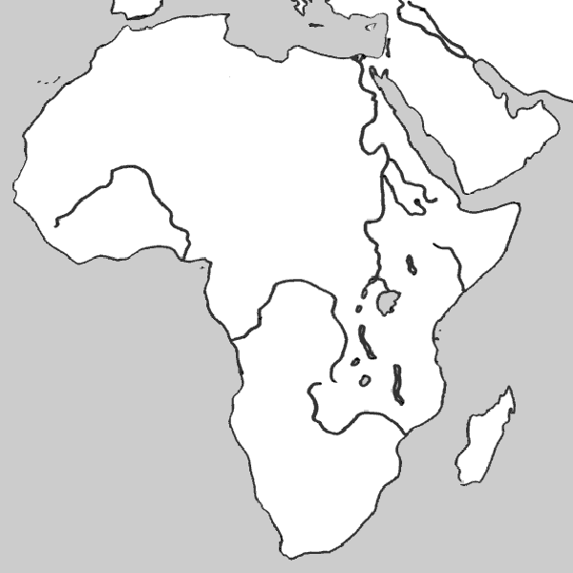v

